**Rock Blaster**

1. Add a backdrop from the Backdrop library (Stars).
2. Delete the cat sprite.
3. Add the Rocketship sprite from the sprite library.
4. Open the Costumes tab and rotate the first costume of Rocketship 90 degrees clockwise.

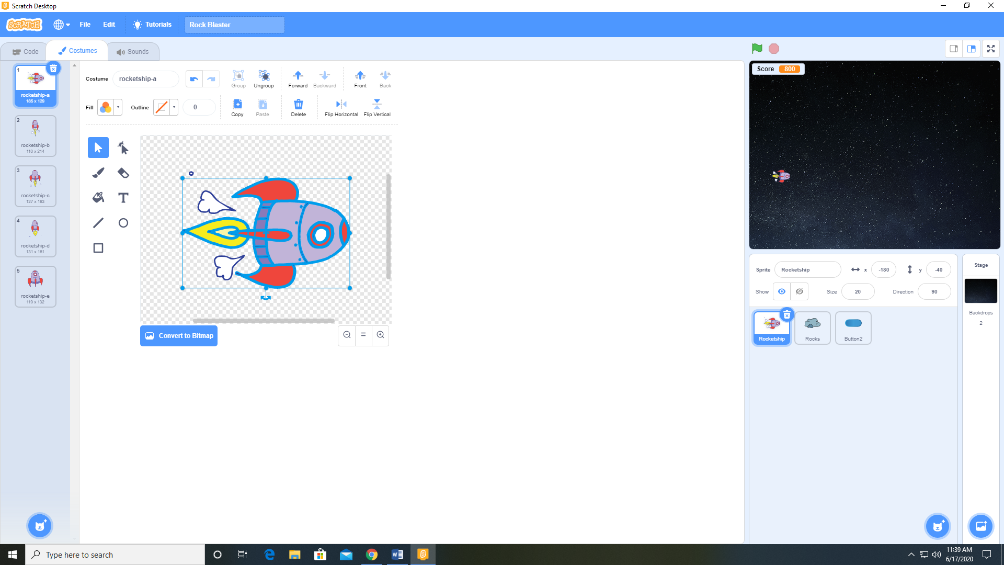

1. Add a variable Score available to all sprites and visible to the desktop.
2. Add a sprite from the sprite library (Button 2)
3. Add a sprite from the sprite library (Rocks)
4. Add the following code to the Button 2 sprite.

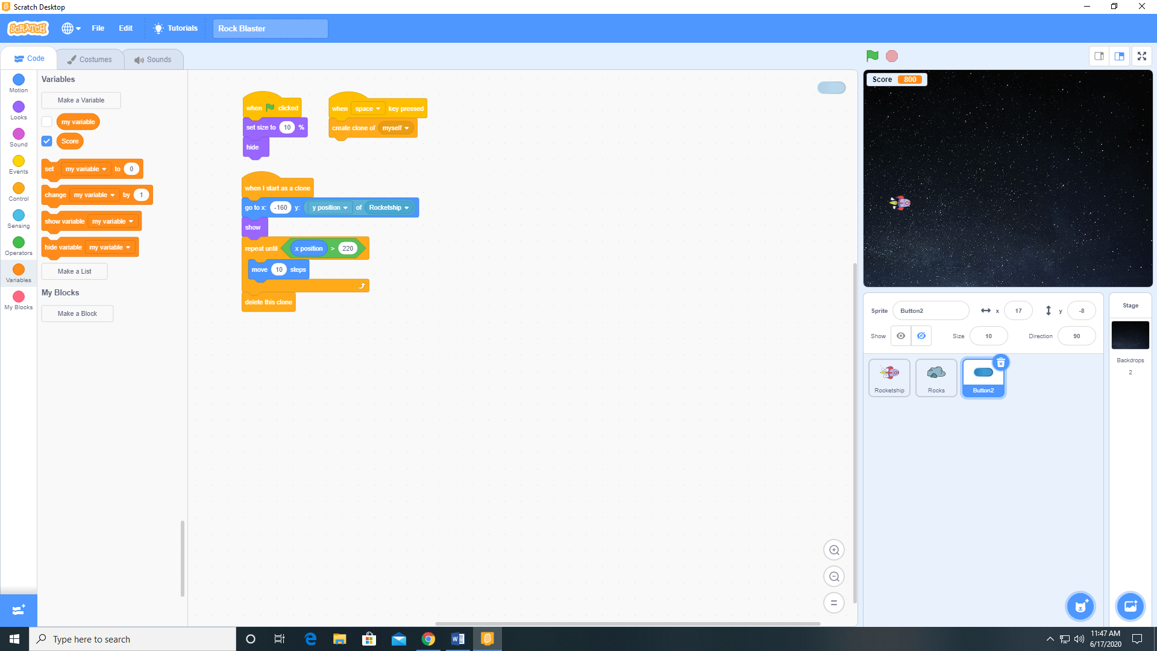

1. Add the following code to the Rocketship sprite.

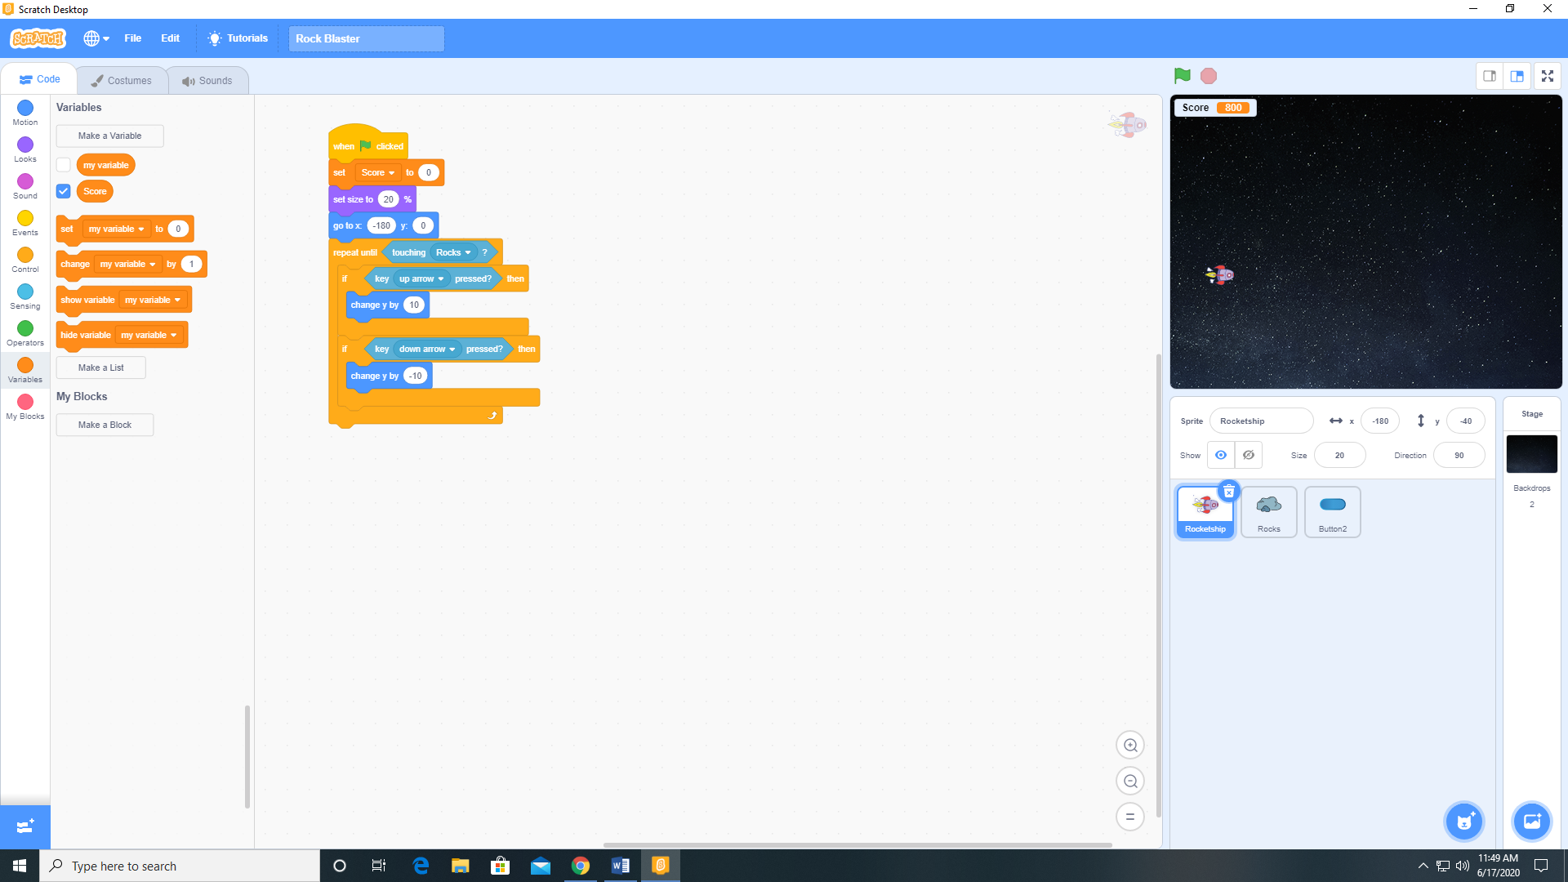

1. Add the Water Drop and Cymbal Crash sounds to the Rocks sprite from the sound library.
2. Add the following code to the Rocks sprite.

